

Complaint form

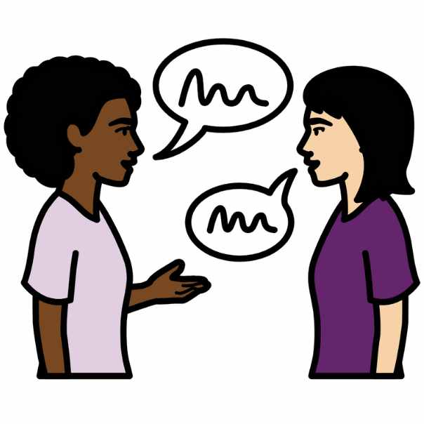

 | About this book
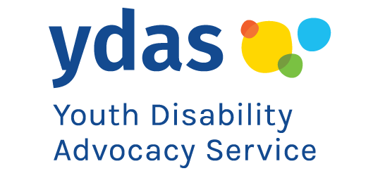 | This book is from Youth Disability Advocacy Service.
 | We are also called YDAS.
 | We help disabled people who
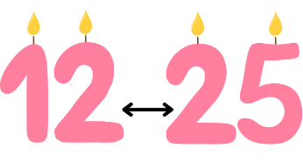 | - are 12 to 25 years old
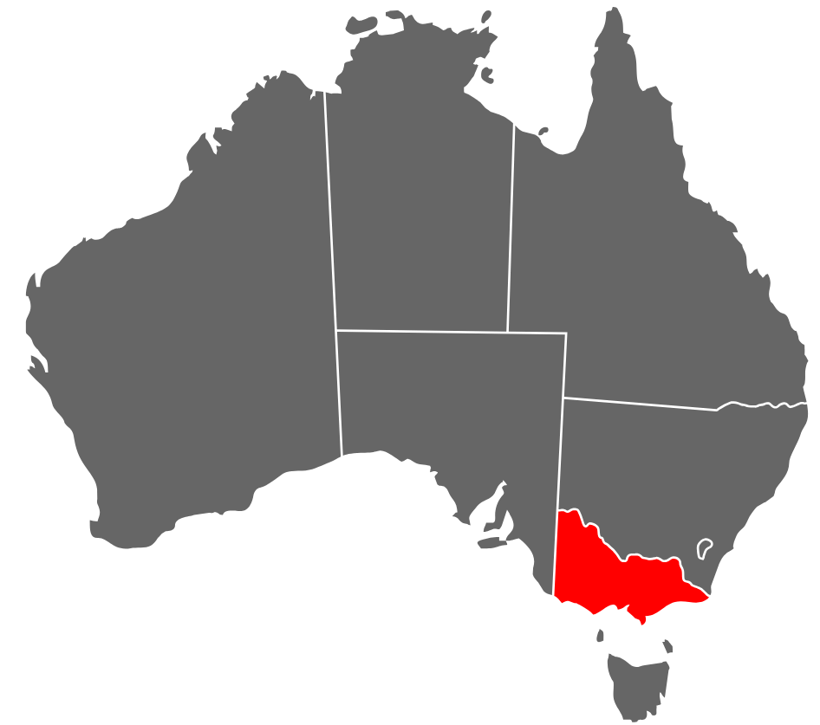 | - live in Victoria.
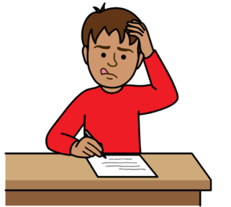 | This book has some hard words.  Hard words are bold and purple.
 | We write what hard words mean.
 | This book is our complaint form.
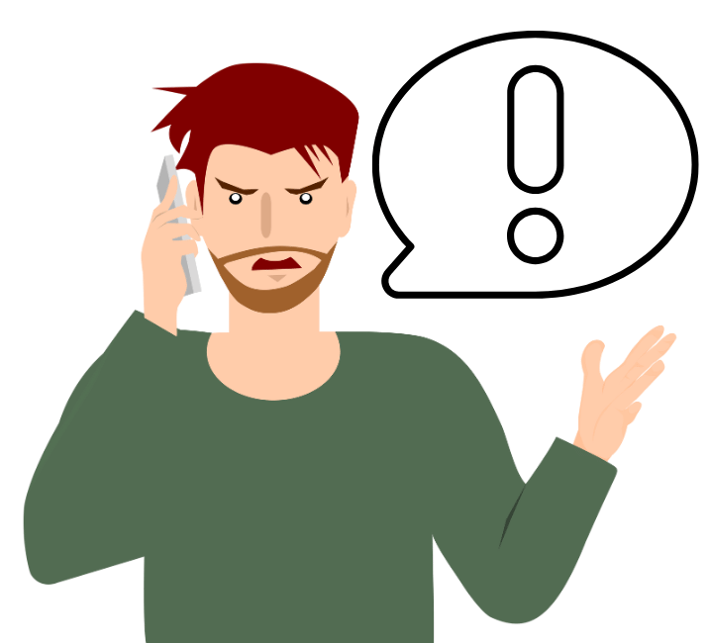 | A complaint is when you tell us you are not happy with our work.
You can tell us about a problem with any part of
our work.
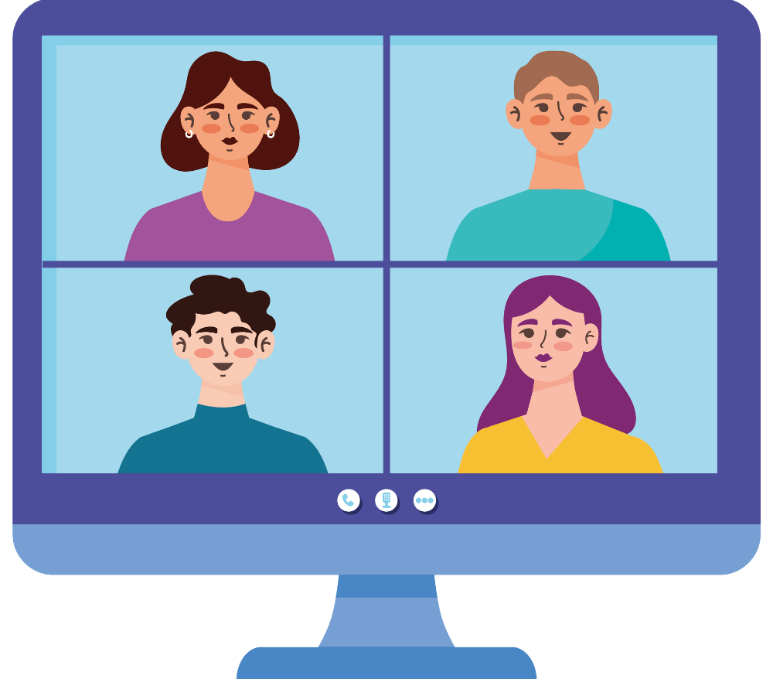 | For example, you can tell us about a problem with our programs.
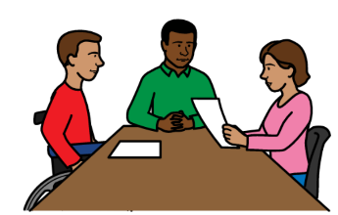 | You can tell us about a problem with our advocacy.
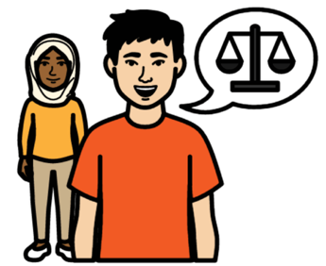 | Advocacy is when we help you speak up about  a problem.
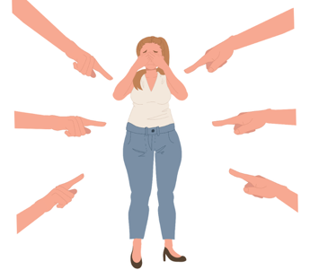 | For example, when someone is not fair to you because of your disability.

 | What we will do
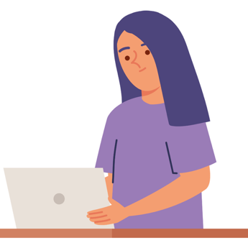 | When we get a complaint we will read it.
 | We will talk to the staff who are part of  the complaint.
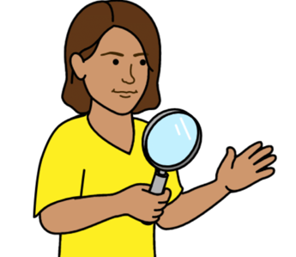 | We might do an investigation.
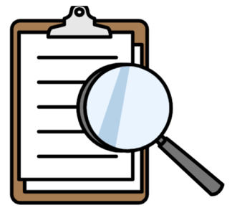 | An investigation means we find out more about  your complaint.
 | We will tell you what we decide to do about  your complaint.

 | How to make a complaint
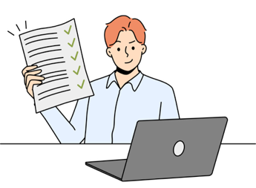 | You can fill in this form to make a complaint.
 | You can be anonymous.
 | Anonymous means we do not know who you are.
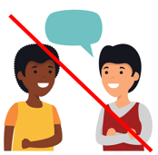 | We cannot tell you what we will do about your complaint if you are anonymous.
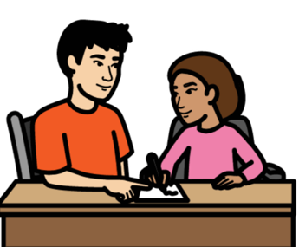 | You can ask for help to fill in the form.

 | Questions about you
 | Tick the box if you
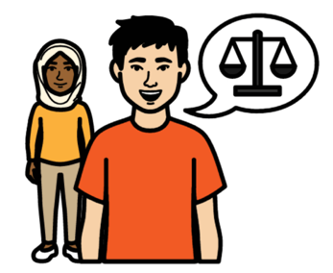 | [] Used our advocacy service
 | [] Were part of a YDAS program or group
 | [] Are making a complaint for a young person
 | [] Want to be anonymous.
 | If you want to be anonymous do not tell us
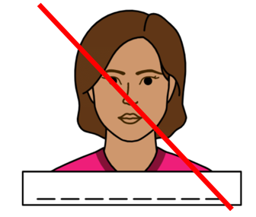 | - your name
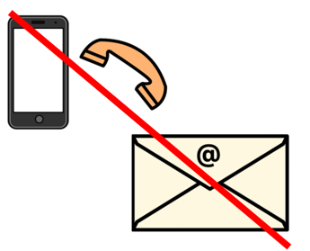 | - how to contact you.
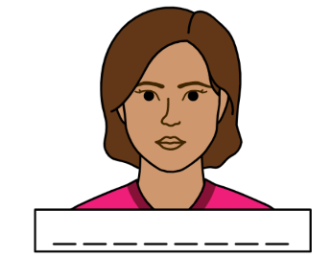 | What is your name?
Write your name here.
[TEXT BOX]
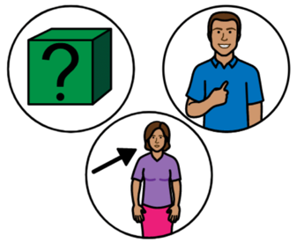 | Pronouns are words we use when we talk  about you.
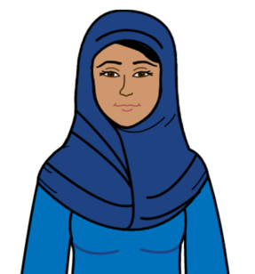 | For example, she and her.
 | What are your pronouns?
Write your pronouns here.
[TEXT BOX]
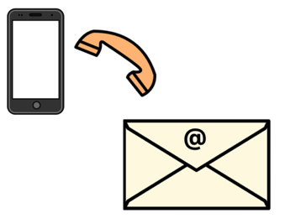 | Do you want us to contact you about  your complaint?
 | [] yes
 | [] no.
 | How we can contact you
 | What is your phone number?
Write your phone number here.
[TEXT BOX]
 | What is your email address?
Write your email address here.
[TEXT BOX]
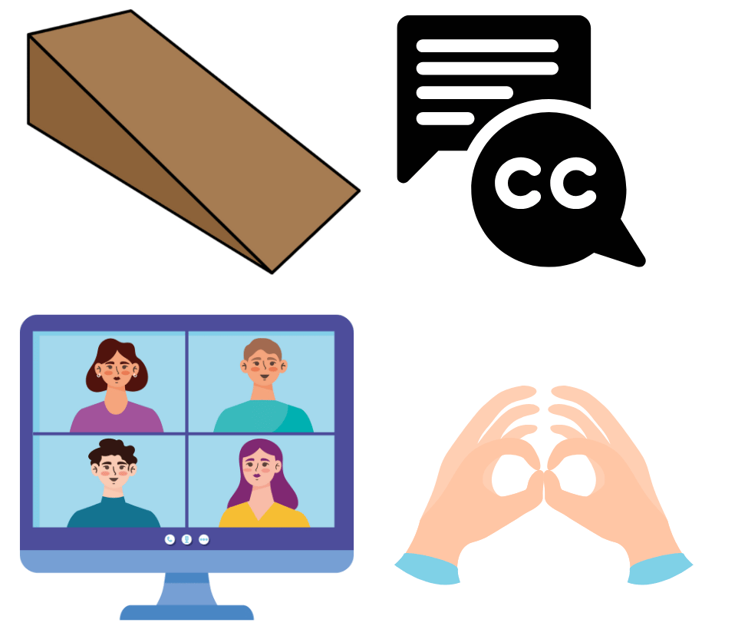 | Access needs are things that help you communicate with us.
 | For example your access needs might be
 | - captions
 | - Auslan.
 | Do you have any access needs?
 | [TEXT BOX]
 | Is someone helping with your complaint?
 | [] yes
 | [] no.
 | Tick a box if we can
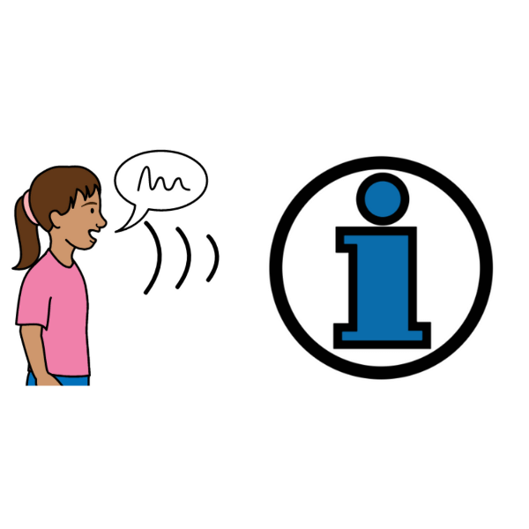 | [] Give the person information about your complaint
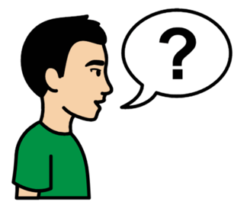 | [] Ask the person questions about your complaint.

 | About your complaint
 | In the box below tell us
 | - What happened
 | - Where it happened
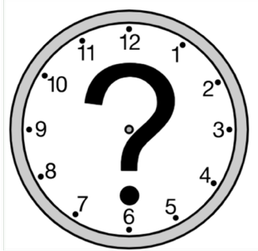 | - When it happened.
 | [TEXT BOX]
 | What do you want to happen to fix the problem?
 | [TEXT BOX]
 | Have you told us about the problem before?
 | [] Yes
 | [] No.
 | If you told us about the problem, what happened?
 | [TEXT BOX]
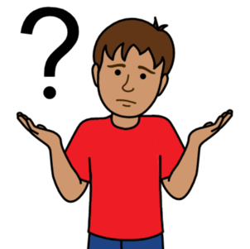 | If you have not told us about the problem before, why not?
 | [TEXT BOX]
 | Privacy
 | Privacy is about how we share the information in your complaint.
 | We will only share information about you if
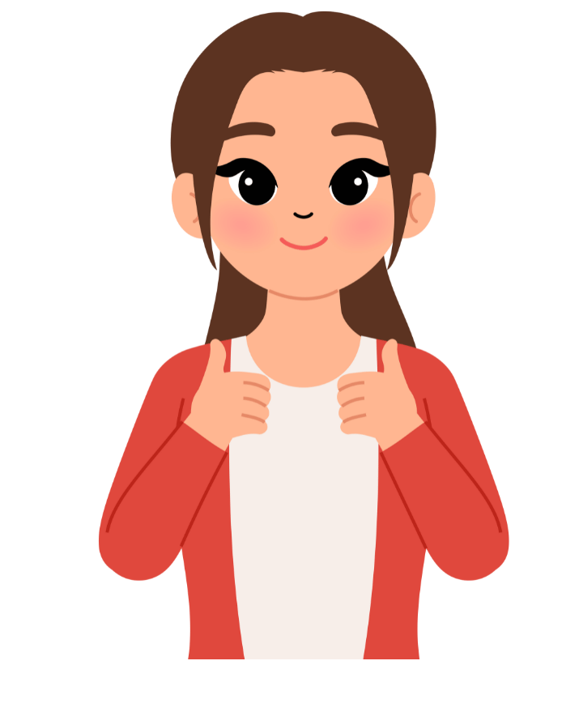 | - the information will help us support you
 | and
 | - you give us consent.
 | Consent means you say we can share  your information.
 | If we think you are not safe we might share information about you.
 | We do not need your consent to share information to keep you safe.
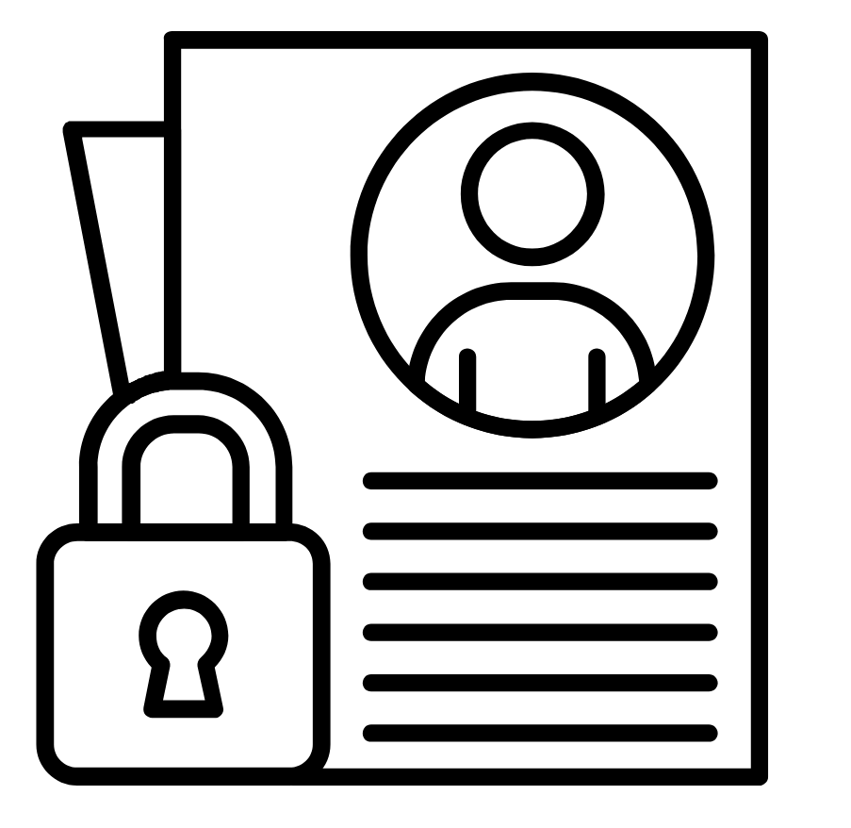 | We will keep your information safe.
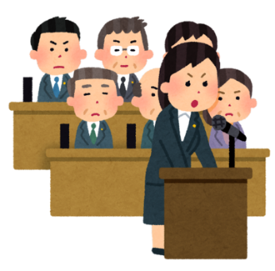 | We have to tell the government about our work.
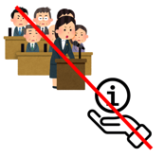 | When we share information with the government, we will not say who you are.
 | You can ask to see what information we have  about you.

Another way to make
a complaint
 | We are a disability service provider.
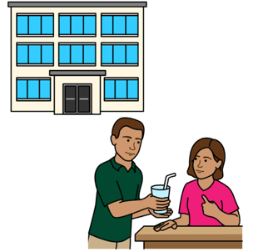 | A disability service provider is any organisation that helps disabled people.
 | The Disability Service Commissioner can help you fix a problem with a disability service provider.
The Disability Service Commissioner can help
when you
 | - want to make a complaint about us
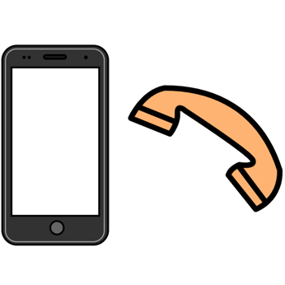 | You can call the Commissioner.
 | 1800 677 342
 | You can email the Commissioner.
 | complaints@odsc.vic.gov.au
 | More information
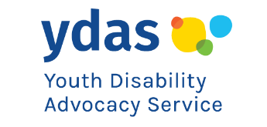 | For more information contact YDAS.
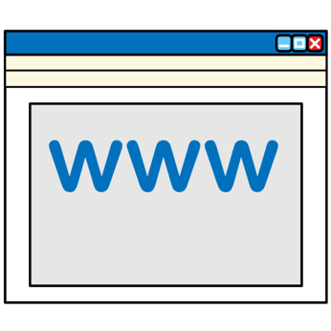 | Website ydas.org.au
 | Email ydasfeedback@ydas.org.au
 | Call 0438 638 734

This book was created using images from Boardmaker and Canva, July 2025. Please do not copy these images or use them in other work.
PCS and Boardmaker are trademarks of Tobii Dynavox LLC. All rights reserved. Used with permission.

